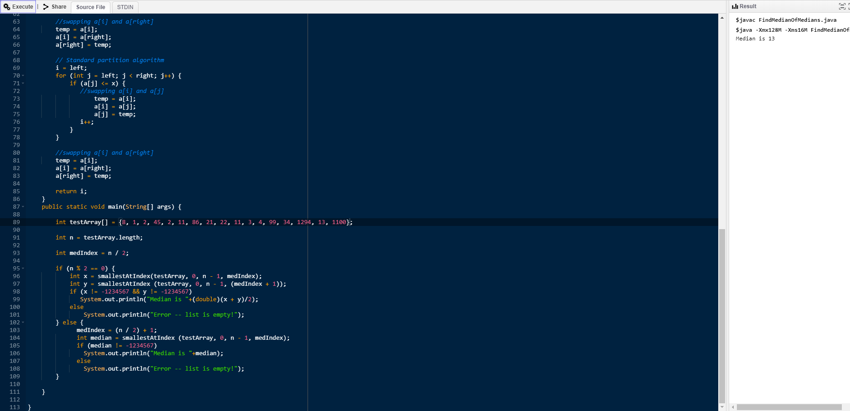

Instructions:

Set testArray[] to any of the above sets. Next, run the program in an IDE or command prompt, or however you execute Java files.

The program will output the median, if there is one.